TECHNICAL REPORT ON STUDENT INDUSTRIAL WORK EXPERIENCE SCHEME (SIWES)

AT
YUSAL TELEVIEW NIGERIA LIMITED,

FROM: OCTOBER, 2024
TO: JANUARY, 2025

BY
DANIS AYUBA
(SE/BT/ND/23/010)

SUBMITTED TO THE DEPARTMENT OF BUILDING TECHNOLOGY, FEDERAL POLYTECHNIC MUBI, IN PARTIAL FULFILLMENT OF THE REQUIREMENT FOR THE AWARD OF NATIONAL DIPLOMA (ND) IN BUILDING TECHNOLOGY

MARCH, 2025
DECLARATION
This is to declare that I, DANIS AYUBA with registration number SE/BT/ND/23/010 undertook my four months SIWES at YUSAL TELEVIEW NIGERIA LIMITED, MUBI SOUTH, ADAMAWAW STATE and have acquired all the experience compiled in this report in the course of my SIWES.

……………………………….. ……………………………
DANIS AYUBA Sign/Date
(SE/BT/ND/23/010)

CERTIFICATION
This is to certify that this report compiled by DANIS AYUBA (SE/BT/ND/23/010) meets the regulations of governing the award of National Diploma (ND) of the Federal Polytechnic Mubi, and is approved by:

………………………………. ……………………
Name of Supervisor Date
Departmental Supervisor

………………………………. ……………………
Mr. Mohammed Auta Date
Departmental SIWES Coordinator

…………………………………. ……………………
Builder Godwin Zira Hyalaba Date
Head of Department
DEDICATION
I dedicate this technical report to my parents, my sisters and colleagues and to all those that supported me throughout the industrial training.

ACKNOWLEDGEMENTS
First of all, my sincere appreciation goes to Almighty God and salutation to my Lord Jesus Christ.
I wish to thank all staff of Building Technology Department in Federal Polytechnic, Mubi.
My appreciation goes to my beloved parent for the motivation, prayers and financial support towards my SIWES exercise.
My special thanks go to my beloved brothers and sisters for all their care and support throughout my industrial training.
I want to also thank my colleagues and others; I really appreciate your efforts.

TABLE OF CONTENTS
TITLE PAGE………………………………………………………………… i
DECLARATION…………………………………………………………….. ii
CERTIFICATION………………………………...………….………………. iii
DEDICATION………….………………………..………….……………….. iv
ACKNOWLEDGEMENT……………………………………….……………v
TABLE OF CONTENTS…………………………………..…….……………vi
ABSTRACT……………………………………………………….…………. viii
CHAPTER ONE
1.0 Introduction……………………………………………………………….1
1.1 Aims and Objectives of SIWES………………………………………….. 1
1.2 Brief history of SIWES……………………………………………………2
1.3 Significance of SIWES………………………………………..…..……… 3
CHAPTER TWO
  - Brief History of Organization………………………..……........................ 4
2.2 Organogram……..………………………………………..……................. 4
CHAPTER THREE
3.0 Description of work experience……..………………………………… 5
3.1 Excavation……..……………………….……………………………….5
3.2 Block work……..……………………….………………………………6
3.3 Casting……..……………………….…………………………………. .7
3.4 Setting of pillars and column base……..……………………………….8
3.5 Blinding……..……………………….………………………………… 9
CHAPTER FOUR
4.0 Summary, Recommendation and Conclusion…………………………. 10
4.1 Problems observed during my program………….…………..……….. 10
4.2 Summary……..…………………………………………………………10
4.3 Conclusion……..……………………………………………………….11
4.4 Recommendations……..………………………………………………. 11
Reference. ………………………………………..……................................... 12

ABSTRACT
Student Industrial Work Experience Scheme is a skill training designed to expose and prepare student in institution of higher for industrial working situation they may likely meet after graduation. The report summarizes the result of work done during my SIWES experience, the technical report consists of four chapters, which comprises of introduction, history and criteria’s of SIWES in chapter one followed by their aims and objectives, historical background, organizational structure of the organization in chapter two, while chapter three consist of Site layout, Site Clearance, Setting out using 3-4-5 method, Excavation, Block Work, setting of Pillars and column base, which are the work actually carried out during the SIWES programme and lastly chapter four consist of the problems encountered, summary, conclusions and recommendations.

CHAPTER ONE
1.0 INTRODUCTION
SIWES meaning “Student Industrial Work Experience Scheme” is a skill training designed to expose and prepare student in institution of higher for industrial working situation they may likely meet after graduation. The scheme is meant to train student on the method of work and the experience needed in handling the equipment and machines may not be available in their institution. The scheme is financed by the Federal Government and operators through Industrial Training Fund (ITF), Ogwo, (2001) and operates with National University Commission (NUC), National Board of Technical Education (NABTEC), and National Commission for College of Education (NCCE) and industries. However, SIWES also expose the student to many practical works which the institution did not treat in details without plastering what the institution taught theoretically. SIWES assist the student to understand the nature of his/her work in future.

1.1 Aim of SIWES
The aim of this Student Industrial Work Experience Scheme (SIWES) is to expose the students to work experience and practicals.

1.2 Objectives of SIWES
- It helps the students to gain work experience during the Student Industrial Work Experience Scheme (SIWES).
- To identify proper work experience on Architectural designs and working drawing during Student Industrial Work Experience Scheme (SIWES).
- To study and adopt Architectural design during the Student Industrial Work Experience Scheme (SIWES) etc.

1.3 Brief history of SIWES and ITF in Nigeria
It was said by Dr. Azikiwe Nnamdi, the one president of Nigeria that the practice of work but they all have the same goal that they all want to achieve in countries like china. They established within the premises of institution to provide real life situation, lack of practical skill of locally trained engineers and technologies. the Chinese way and condition of SIWES is that all institutions must give students real life working experience in industrial works. Lecturers are involved in the industrial activities rendering constant services. So, all these countries have their own way of conducting the scheme but all lay on the same goal, and in Nigeria, the history of SIWES can be traced by the history of ITF which is the backbone of SIWES. ITF was established in 1974 under degree 47 of 1971 (Edward, 2003). It was a body established by the Federal Government of Nigeria and was given responsibility of training indigenous Nigerians. The establishment of the body became necessary due to high demand of Nigeria to take up the vacant positions created in various sector of the economy after the colonial masters have departed. Therefore, the Federal Government discovered that it is easier to train students that are skilled in school to be trained and meet up with gaps in the Nigerian economy and a scheme was established to care for such training and it was named Student Industrial Work Experience Scheme (SIWES). In 1973, the National Board of Technical Education (NBTE) made it compulsory for all the polytechnic students, be it federal or state (Francis, 2012).

1.3 Significance of SIWES to students
Principles taught in the classroom are vein forced given concrete applications on the industrial assignment and students is able to see the relevance of their students which increase their motivation. It helps in gave students the knowledge on the types of work to do after his/her graduation. SIWES given students opportunity for a change of environment as they move their institution to the place of attachment which changes the routine types of environment to a word of work. It helps in connecting the relationship between institution and the industry.

CHAPTER TWO
2.1 BRIEF HISTORY OF YUSAL TELEVIEW NIGERIA LIMITED
Yusal Teleview is a civil engineering construction company providing service on all forms of civil engineering works. It was incorporated in Mubi, Nigeria, with registration number 889210. It was registered on 26th May 2010. Civil engineering construction works include road construction projects throughout Nigeria. It works for both the public and private sectors on small and large projects. It has achieved a reputation for timely delivery and innovation management.
The experience of Yusal Teleview stretches over ten years. The past years of operation in Nigeria have seen Yusal Teleview complete a number of successful projects. The company has developed the experience and system to mobilize within a short period of time, technical staff, management personnel, and labor, to organize them into fully integrated teams. It is because Yusal Teleview has a pool of multi-national human, material, and technology resources that it is capable of assuming total project responsibility and of providing a comprehensive project delivery program, which includes engineering labor that will be drawn from either Yusal Teleview’s current project organization or will be recruited after careful screening from the local area.
Yusal Teleview operates a planning and management system based on Microsoft Project. The system encompasses the activities of planning, engineering, document control, and material control. This total management package allows the effective scheduling of all activities in a “real-time” environment, giving the level of control to allow the effective management of multiple contracts in one facility. It is the company’s policy to maintain a safe and healthy working environment for all its employees. The Managing Director is ultimately responsible for the implementation of a documented company health and safety policy. However, through a system of documented working instructions, the responsibility for the physical enforcement of the safety policy will be delegated to other senior managers and supervisors for their particular area.
2.2 ORGANIZATIONAL CHART
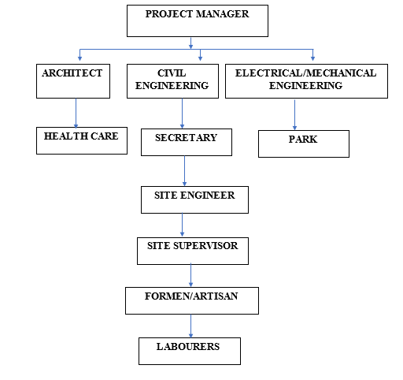

Figure 2.1: Organogram

CHAPTER THREE
3.0 DESCRIPTION OF WORK EXPERIENCE
3.1 SITE LAYOUT
Any site that is being considered for construction has to be arranged in such a manner as to facilitate easy circulation materials machines and workers. The information obtained during site investigation together within preliminary assessment requirement are essential for good site layout. The following were taking in consideration when preparing for site layout on construction site during my (IT) period.
Accessibility: Access route to and from the site were checked and considered to ensure easy transportation of materials and plant to the proposed site. On site access for delivery and general circulation also be considered.
Storage: The materials on site were stored for security and against weather protection is an important consideration for good site layout. A location of adequate areas for storage and working space around the storage is required to reduce double handling of materials to the beeriest.
Accommodation: The staff of the company were denied the right to accommodation due to the problem of theft on the site. The appropriate accommodation provision made a reasonable mesh room, toilet and bathroom inside the site in other to reduce the working time minimum.
Plant: The number of plant expected or required were anlysed, if plant is expected a hard standing is necessary while circulation route for mobile plant were checked for maximum efficiency.
Security: The need for fencing or hording was considered in other to in carry local vandalism and theft on site.
The site layout is one of the most important initial site preparations before any setting out will commence.
3.2 SITE CLEARING
- All grasses were cleared at site.
- All unwanted stones were removed
- All hazardous objects noticed at site were removed
- The site was ensured save before work commenced.
3.3 SETTING OUT
3-4-5 method was used for the setting out, as observed after 90º from all angles using the pegs, ropes, string and also the plan.
Setting out is done with high degree of accuracy or else the building will not last as the engineer answered to my question “why are some calculations made during setting out”.
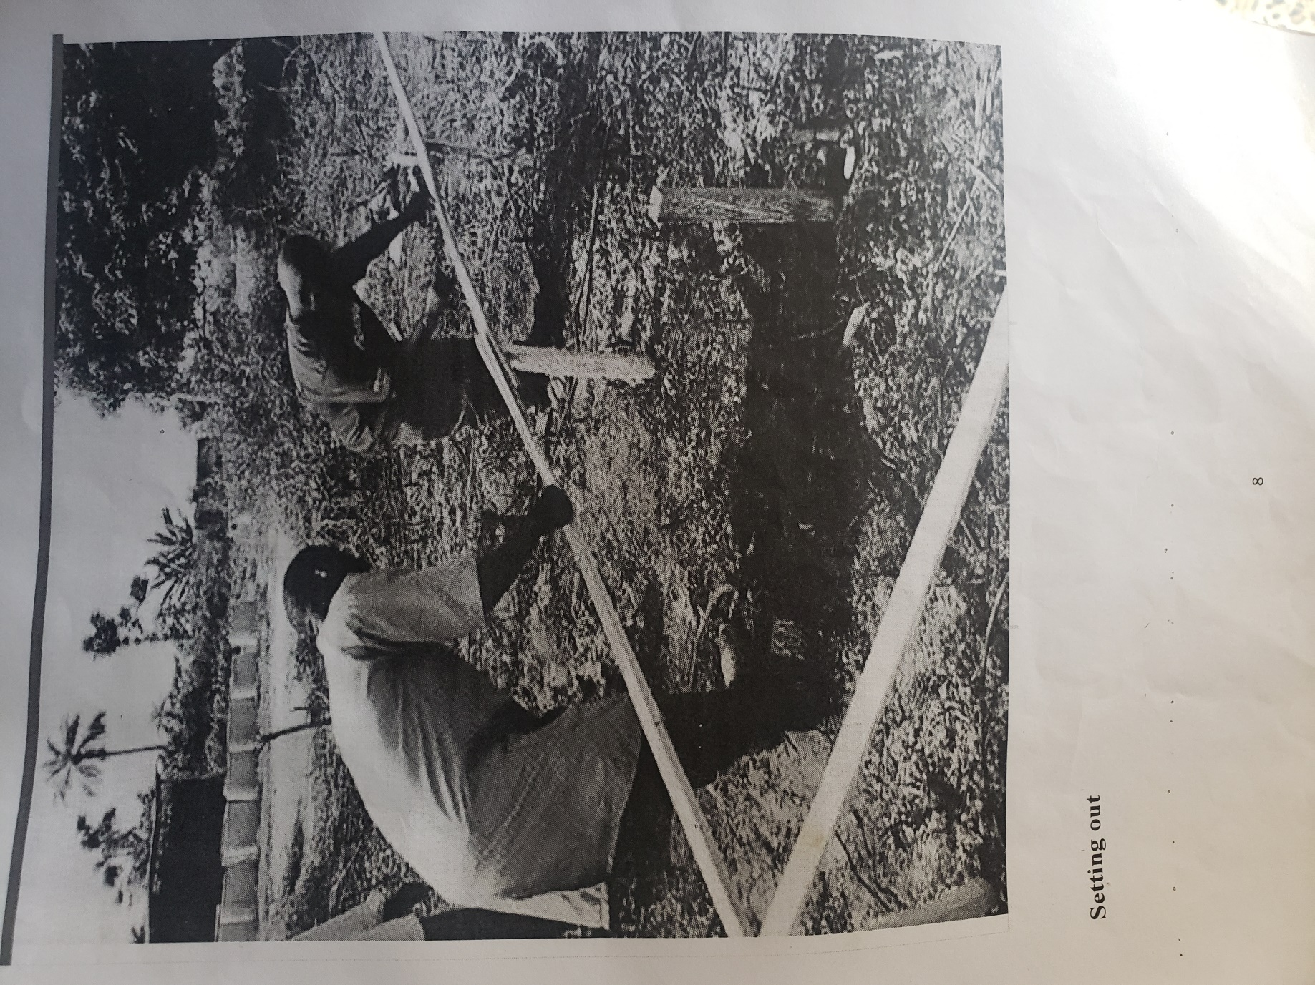
Plate 3.1: Setting out using profile board
Source: Author’s work, 2025

3.4 EXCAVATION
Excavation was a vital part of our construction process, involving the loosening and removal of earth or rocks from their original positions, and transporting them to spoil banks. This step was typically performed immediately after setting out. We relied on an excavator to handle the excavation work efficiently. Drainage trenches were dug to a depth of 1000mm and a width of 1000mm to ensure proper drainage.
- Nature of the soil
- The width and depth of foundation
- Climatic condition at the time of excavation
- The water table of the soil
- The period excavation work is expected to be left open.
- The effect of excavation on existing adjacent structure.
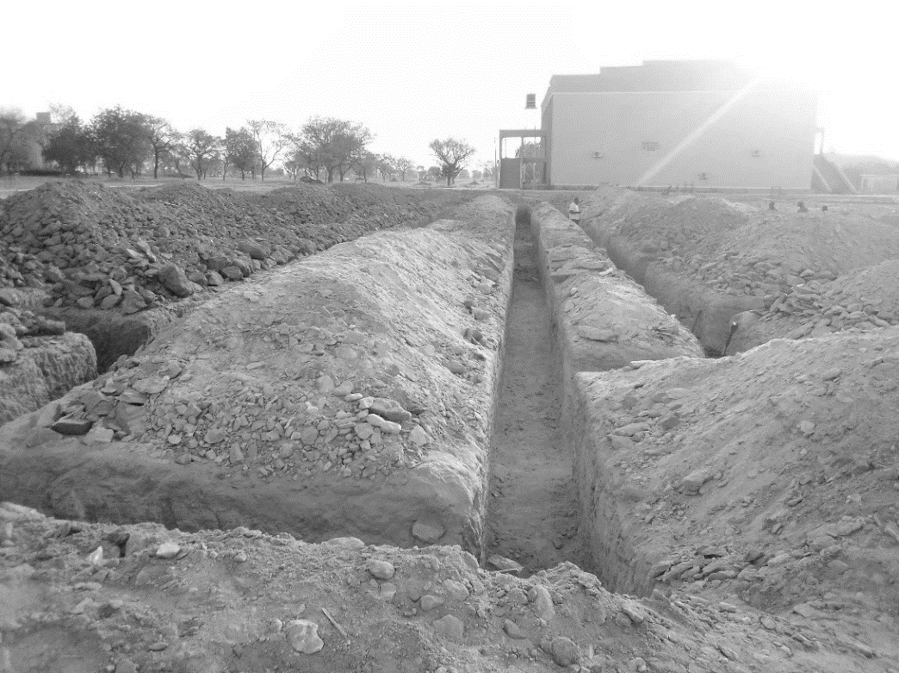

Plate 1: Excavation
Source: Author’s work, 2025

3.5 BLOCK WORK
Blocks were molded in a number of sizes, various compositions, strengths, and shapes such as 9 inches and 6 inches. The 9-inch blocks were used for external walls, while the 6-inch ones were for internal walls. After the foundation work was finished, the blockwork was built to cover the spaces as well. All the blockwork did not carry any load; they were erected to cover spaces and also act as partition walls.
PROCEDURE
- Before starting the block laying process, the site was prepared by clearing debris and ensuring a level foundation.
- The layout of the walls or structure was marked using chalk lines or strings to guide the placement of the blocks.
- Blocks or bricks were selected based on the desired strength, size, and aesthetic requirements of the project.
- Mortar was mixed according to the specifications, typically using a combination of cement, sand, and water.
- A layer of mortar was spread evenly along the foundation where the first course of blocks would be placed.
- A level was used to check the horizontal and vertical alignment of the blocks.
- Once the first course was laid, additional courses of blocks were added on top, following the same process.
- Each block was buttered with mortar on its ends before being placed to ensure a strong bond between the blocks.
- Blocks may have needed to be cut to fit around corners, openings for doors or windows, or to maintain the desired pattern.
- Excess mortar was scraped off the joints using a trowel, and any gaps or voids were filled to create a smooth, uniform surface.
- Once the block laying was complete, the work area was cleaned up, and any excess materials or debris were removed from the site.
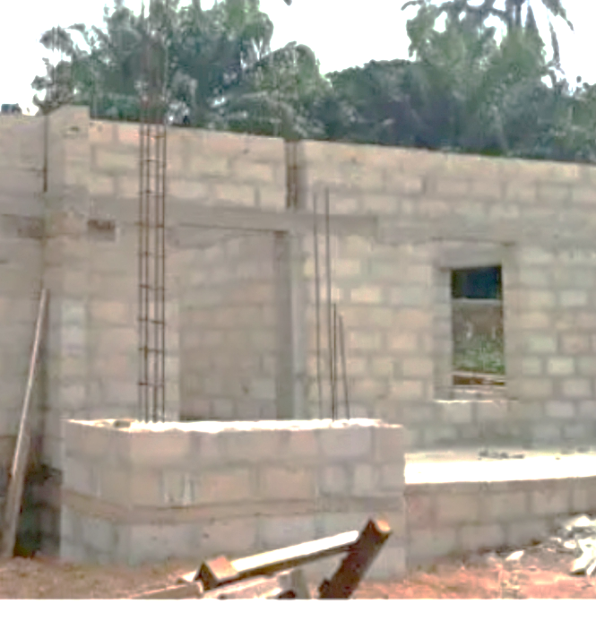
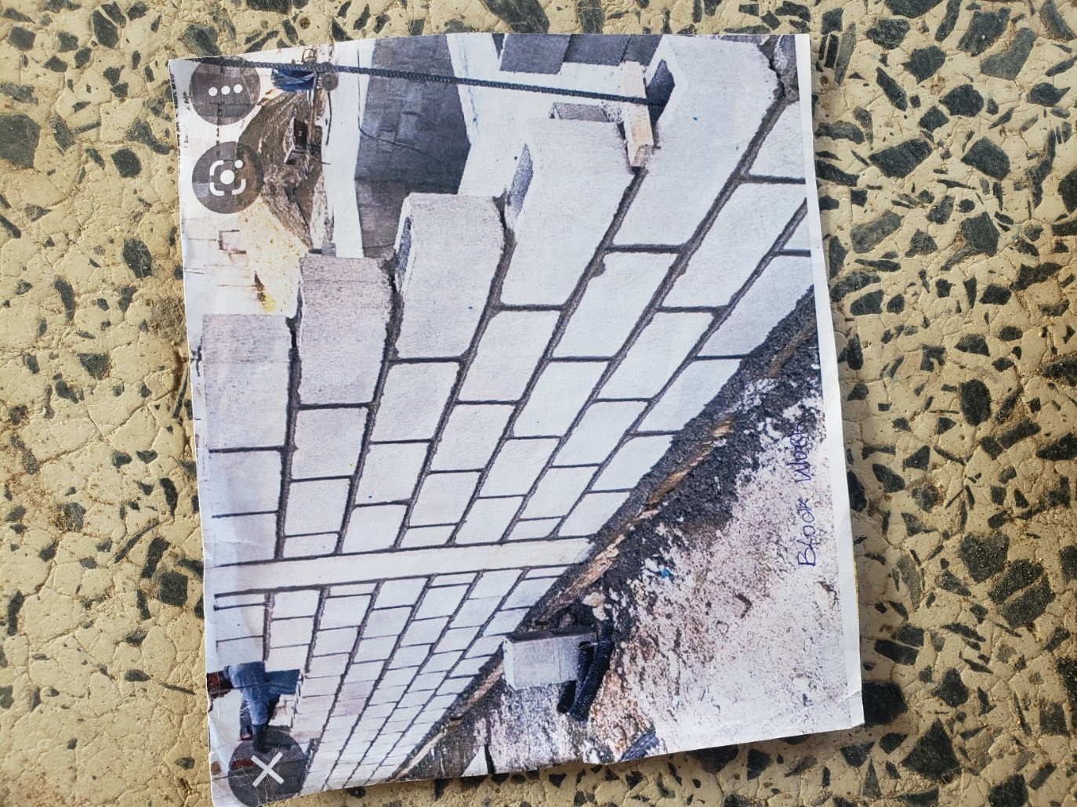
Plate 2: Block work Plate 3: Block work
Source: Author’s work, 2025

3.4 SETTING OF PILLARS AND COLUMN BASE
We usually tie a rope to out or in-to-in and then place our pillar in the middle of the block to make it align and in straight line.
After putting the baskets in their respective positions, the pillars are then set with the ropes (crossed in between the ropes). Then we made sure that the pillar is not touching the rope, and then tied it to the basket with the blinding wear, stroke in the middle of the pillar with braces so that to hold it in position and in line. After that concrete mix is then applied to fill in the 1 feet depth carefully without tempering with the position of the pillar and then being rammed.
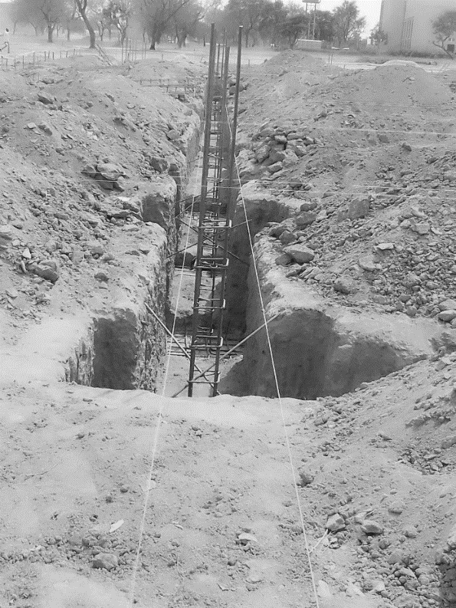
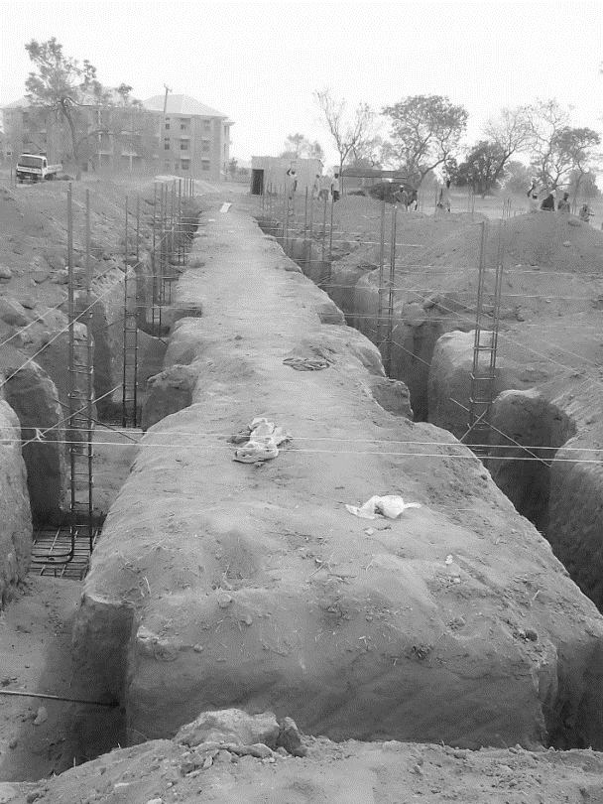
Plate 4: Blinding
Source: Author’s work, 2025

CHAPTER FOUR
4.0 SUMMARY, RECOMMENDATION AND CONCLUSION

4.1 PROBLEMS OBSERVED DURING MY PROGRAM
- The time frame set for the program is too short as some of the aspects of the program where not completed.
- Lack of Financial support from the company to aid transportation to and from training.
- Attentions are not given to the IT students by the workers it is learn if you want to learn or ask if you want to know.

4.2 SUMMARY
One would state that the discipline is the training of the mind and body towards effective performance. The Students Industrial Work Experience Scheme (SIWES) is more or less achieving this fit. As it further builds on the theoretical classrooms leaving a practical approach of the industry and commerce to supply of finished goods and services. This program has enabled the participating students to be practically involved in the day-by-day activities of the industries and commerce.
Emphasis in the observation of industrial safety rules and regulations, time critical operation and proper man-hand management, quality cortices, etc. are daily activity objective. All those aimed at the production of marketable goods and services in the world of work.
However, to consolidate on the gains of this Industrial Training Fund (ITF) higher institution coordinator on SIWES program should be allowed making some suggestion and recommendation.
4.3 CONCLUSION
SIWES programme is very vital student especially undergraduates, because I come to see the SIWES programme provide an application of the theoretical knowledge learned by student in school to practical or real work situation. Also, it is a medium where student from different higher institutions and department come together sharing idea there, by promoting an avenue for learning and them work.
4.4 RECOMMENDATIONS
Having being exposed to a bit of what entail working in an individual related to my course of study under SIWES programme I wish to make this recommendation
- Higher instruction of learning especially either institution and universities should establish link with comprise and establishment so as to provide space for student on industrial attachment, with the option of gaining employment in future, by doing so, it will go a long way in alleviating suffering and difficulties encountered by student in securing place for individual attachment.
- Student should put money as the primary aim of going SIWES programme, there is more to learn than Bain allowance.

REFERENCES
Chudley, R. (2005). Construction technology volume 2. Pearson Prentice Hall, New York.
Edward, B. (2003). The Effect of SIWES on a student, Federal Ministry of Works, Lagos. Nigeria.
Francis, K. (2012). Building Construction Illustration. (Fourth Edition). Wiley Publisher. ISBN-10: ‎ 9788126535637.

